**Topic: Perimeter, Area, Surface Area and Volume**

Time: 45 mins Marks: /45 marks

**No calculator allowed**



**Question One: [2, 3, 3: 8 marks]**

Calculate the perimeter of the following shapes. Diagrams are NOT to scale.

a)



b)



c)

**Question Two: [3, 3, 2: 8 marks]**

a) Calculate the area of the following shapes.

i)

ii)

b) A rectangle’s height is twice the length of its base. If it has a height of 10 cm, calculate its area.

**Question Three: [2, 6: 8 marks]**

****a) Calculate the surface area of this dice if each face is 2 cm by 2 cm.

b) This is the foam structure inside a child’s chair.

The base face is a square and each piece of foam is 2 cm thick.

The foam is to be covered in fabric. Calculate the total amount of fabric required to completely cover the outside of the chair, including the base.

**Question Four: [2, 4, 2, 1: 9 marks]**

A leading toy manufacturer has come out with a brand new educational product. They are called Bucket Prisms and they are buckets in the shape of different prisms rather than all being cylindrical. They come in a range of sizes and shapes.

Anthony is playing with his prism buckets. He has one large one and one smaller one as shown below.

The smaller bucket is half the height of the larger bucket (not including the handles). And the base of the smaller bucket is two identical trapeziums joined by their longest side.

a) Calculate the volume of the large bucket.

b) Calculate the area of the base of the small bucket.

c) Using part b) or otherwise, calculate the volume of the smaller bucket.

d) If Anthony fills the large bucket with water and then from the large bucket of water he fills the small bucket, how much water is left in the large bucket?

**Question Five: [6, 2, 4: 12 marks]**

Sandy, Danny and Franky are playing at the beach. Sandy is tracing pictures in the sand, Danny is digging holes and Franky is building sand castles.

a) Calculate the perimeter and area of Sandy’s picture in the sand.

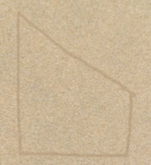

60 cm

20 cm

30 cm

b) Danny draws the oval pictured below which has an area of 60 cm2. He then dug down in this shape 20 cm deep. Danny’s hole was near the shore and a wave came and filled it up with water. Calculate the capacity of the hole that Danny created.

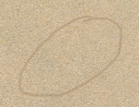

c) Franky has built a sand castle which is a cube on top of a cube. The large cube has faces 15 cm by 15 cm and the small cube is a cube of black beech wood she found on the beach.

i) The volume of the small cube is 125 cm3. What is the side length of the small cube?

ii) Franky notices that the large cube is *n* times larger than the small cube. Calculate the value of *n*.

**Perimeter, Area, Surface Area and Volume SOLUTIONS**

Time: 45 mins Marks: /45 marks

**No calculator allowed**



**Question One: [2, 3, 3: 8 marks]**

Calculate the perimeter of the following shapes. Diagrams are NOT to scale.

a)







b)



c)



**Question Two: [3, 3, 2: 8 marks]**

a) Calculate the area of the following shapes.

 i)



ii)



b) A rectangle’s height is twice the length of its base. If it has a height of 10 cm, calculate its area.





**Question Three: [2, 6: 8 marks]**

****a) Calculate the surface area of this dice if each face is 2 cm by 2 cm.





b) This is the foam structure inside a child’s chair.



The base face is a square and each piece of foam is 2 cm thick.

The foam is to be covered in fabric. Calculate the total amount of fabric required to completely cover the outside of the chair, including the base.



**Question Four: [2, 4, 2, 1: 9 marks]**

A leading toy manufacturer has come out with a brand new educational product. They are called Bucket Prisms and they are buckets in the shape of different prisms rather than all being cylindrical. They come in a range of sizes and shapes.

Anthony is playing with his prism buckets. He has one large one and one smaller one as shown below.

The smaller bucket is half the height of the larger bucket (not including the handles). And the base of the smaller bucket is two identical trapeziums joined by their longest side.

a) Calculate the volume of the large bucket.



b) Calculate the area of the base of the small bucket.

c) Using part b) or otherwise, calculate the volume of the smaller bucket.

d) If Anthony fills the large bucket with water and then from the large bucket of water he fills the small bucket, how much water is left in the large bucket?



**Question Five: [6, 2, 4: 12 marks]**

Sandy, Danny and Franky are playing at the beach. Sandy is tracing pictures in the sand, Danny is digging holes and Franky is building sand castles.

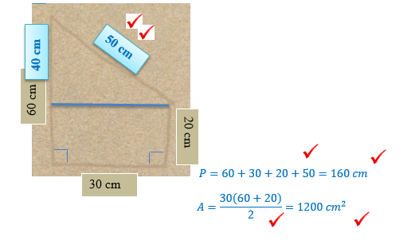

b) Danny draws the oval pictured below which has an area of 60 cm2. He then dug down in this shape 20 cm deep. Danny’s hole was near the shore and a wave came and filled it up with water. Calculate the capacity of the hole that Danny created.



c) Franky has built a sand castle which is a cube on top of a cube. The large cube has faces 15 cm by 15 cm and the small cube is a cube of black beech wood she found on the beach.

i) The volume of the small cube is 125 cm3. What is the side length of the small cube?



$$x^{3}=125$$

$x=5 cm$

ii) Franky notices that the large cube is *n* times larger than the small cube. Calculate the value of *n*.



$5 :15$

$$1:3$$

The large cube is 3 times larger, $n=3$